GROUP 2 MEB MATLAB ASSIGNMENT 5

1. SECANT METHOD
Solve: f(x) = x²−4 = 0,
Using x₀ = 1 and x ₁= 3.
Take tolerance = 10⁻⁶.
x₂ = x₁ − [f(x₁) (x₁−x₀)]/[f(x₁) − f(x₀)]
Since f(x) = x²−4, calculate f(x) for each starting value.

Iteration 1
x ₀ = 1 → f (1) = 1²−4 = −3
x₁=3 → f (3) = 3²−4 = 5
x₂ = 3 − [5(3−1)]/[5−(−3)] = 3 − 10/8 = 1.750000
Error = |1.750000−3| = 1.250000

Iteration 2
x₀=3, x₁=1.75; f (3) = 5; f (1.75) = 1.75²−4 = −0.9375
x₂ = 1.75 − [−0.9375(1.75−3)]/[−0.9375−5] = 1.947368
Error = |1.947368−1.750000| = 0.197368

Iteration 3
x₀ = 1.75, x₁=1.947368; f (1.75) =−0.9375; f (1.947368) ≈−0.208218
x₂ ≈ 2.003559; error ≈ 0.056190

Continue iterations
Iteration 4: x₂ ≈ 1.99995259, error ≈ 0.00360613
Iteration 5: x₂ ≈ 1.99999996, error ≈ 0.00004736
Iteration 6: x₂ ≈ 2.00000000, error ≈ 0.0000000421
Therefore, when the error becomes less than 10⁻⁶, the root is x ≈ 2.00000000.

Secant pseudocode
START
Input x₀, x₁, tolerance, maximum iterations
FOR each iteration
f₀ = x₀^2 - 4
f₁ = x₁^2 - 4
x2 = x1 - f1*(x1-x0)/(f1-f0)
error = ABS(x2-x1)
IF error < tolerance THEN
print x2
STOP
END IF
x0 = x1
x1 = x2
END FOR
END

Secant MATLAB — FOR loop
x0=1; x1=3; tol=1e-6; maxit=20;
for i=1:maxit
f0=x0^2-4; f1=x1^2-4;
x2=x1-f1*(x1-x0)/(f1-f0);
err=abs(x2-x1);
fprintf('%d %.10f %.10f\n',i,x2,err);
if err<tol, break; end
x0=x1; x1=x2;
end
fprintf('Root = %.10f\n',x2);

Secant MATLAB — WHILE loop
x0=1; x1=3; tol=1e-6; maxit=20; i=1;
while i<=maxit
f0=x0^2-4; f1=x1^2-4;
x2=x1-f1*(x1-x0)/(f1-f0);
err=abs(x2-x1);
if err<tol, break; end
x0=x1; x1=x2; i=i+1;
end
fprintf('Root = %.10f\n',x2);
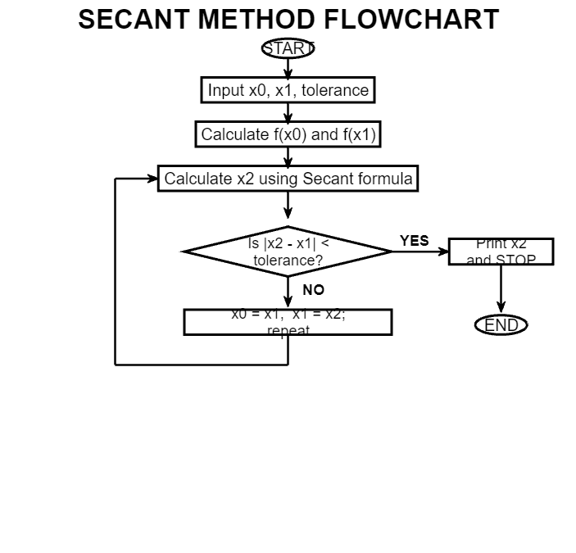

2. NEWTON-RAPHSON METHOD
Solve: f(x)=x³−x−2=0, using initial guess x₀=1.5 and tolerance = 10⁻⁶.

Step 1: Formula
Newton-Raphson formula: xₙ₊₁ = xₙ − f(xₙ)/f′(xₙ).
f(x)=x³−x−2; therefore f′(x)=3x²−1.

Step 2: Iteration 1
At x₀=1.5: f(1.5)=1.5³−1.5−2=−0.125; f′(1.5)=3(1.5)²−1=5.75.
x₁ = 1.5 − (−0.125/5.75) = 1.52173913
Error = |1.52173913−1.5| = 0.02173913

Step 3: Iteration 2
At x₁=1.52173913: f(x₁)≈0.001906; f′(x₁)≈5.94885.
x₂ ≈ 1.52137981; error ≈ 0.00035932

Step 4: Iteration 3
At x₂≈1.52137981, the next approximation is x₃≈1.5213797068.
Error ≈ 9.92×10⁻⁸ < 10⁻⁶, so stop.
Therefore, root ≈ 1.52137971.

Newton-Raphson pseudocode
START
Input x0, tolerance, maximum iterations
FOR each iteration
f = x0^3 - x0 - 2
df = 3*x0^2 - 1
x1 = x0 - f/df
error = ABS(x1-x0)
IF error < tolerance THEN
print x1
STOP
END IF
x0 = x1
END FOR
END

Newton-Raphson MATLAB — FOR loop
x0=1.5; tol=1e-6; maxit=20;
for i=1:maxit
f=x0^3-x0-2; df=3*x0^2-1;
x1=x0-f/df;
err=abs(x1-x0);
fprintf('%d %.10f %.10f\n',i,x1,err);
if err<tol, break; end
x0=x1;
end
fprintf('Root = %.10f\n',x1);

Newton-Raphson MATLAB — WHILE loop
x0=1.5; tol=1e-6; maxit=20; i=1;
while i<=maxit
f=x0^3-x0-2; df=3*x0^2-1;
x1=x0-f/df;
err=abs(x1-x0);
if err<tol, break; end
x0=x1; i=i+1;
end
fprintf('Root = %.10f\n',x1);
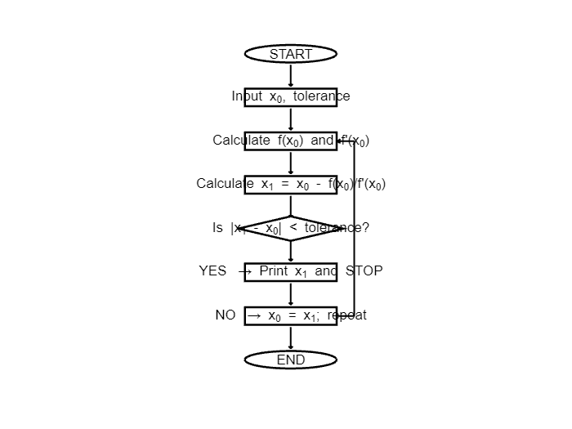

3. FOURTH-ORDER RUNGE-KUTTA (RK4)
Solve dy/dx=x+y, with y(0)=1, using h=0.1. Find y at x=0.5.

Step 1: RK4 formulas
k1 = h f(xn,yn)
k2 = h f(xn+h/2, yn+k1/2)
k3 = h f(xn+h/2, yn+k2/2)
k4 = h f(xn+h, yn+k3)
yn+1 = yn + (k1+2k2+2k3+k4)/6

Step 2: First step, x=0 to 0.1
x₀ = 0, y₀ = 1.
k1 = 0.1(0+1) = 0.100000
k2 = 0.1(0.05+1.05) = 0.110000
k3 = 0.1(0.05+1.055) =0.110500
k4 =0.1(0.1+1.1105) =0.121050
y₁=1+(0.1+2(0.11)+2(0.1105)+0.12105)/6 = 1.11034167.

Step 3: Second step, x=0.1 to 0.2
Using x=0.1, y=1.11034167:
k1=0.12103417, k2=0.13208588, k3=0.13263846, k4=0.14429801.
y₂=1.24280514.

Step 4: Remaining steps
Step 3: y₃ = 1.39971699 at x=0.3.
Step 4: y₄ = 1.58364848 at x=0.4.
Step 5: y₅ = 1.79744128 at x=0.5.
Therefore, y(0.5) ≈ 1.79744128.

RK4 pseudocode
START
Input x, y, h and number of steps n
FOR i = 1 to n
k1 = h*f(x,y)
k2 = h*f(x+h/2,y+k1/2)
k3 = h*f(x+h/2,y+k2/2)
k4 = h*f(x+h,y+k3)
y = y + (k1+2*k2+2*k3+k4)/6
x = x + h
END FOR
Print x and y
END

RK4 MATLAB — FOR loop
x=0; y=1; h=0.1; n=5;
f=@(x,y)x+y;
for i=1:n
k1=h*f(x,y);
k2=h*f(x+h/2,y+k1/2);
k3=h*f(x+h/2,y+k2/2);
k4=h*f(x+h,y+k3);
y=y+(k1+2*k2+2*k3+k4)/6;
x=x+h;
end
fprintf('x=%.1f, y=%.8f\n',x,y);

RK4 MATLAB — WHILE loop
X = 0; y = 1; h = 0.1; n =; i = 1;
f = @ (x, y) x + y;
while i < = n
k1 = h*f (x, y);
k2 = h*f (x + h/2, y + k1/2);
k3 = h*f (x + h/2, y+k2/2);
k4 = h*f (x + h, y+k3);
y = y+(k1+2*k2+2*k3+k4)/6;
x = x + h; i = i+1;
end
f print f ('x=%.1f, y=%.8f\n', x, y);
